**Lesson 12 activities**

**Activity 12.1**

**For loops**

* Copy and run this program.

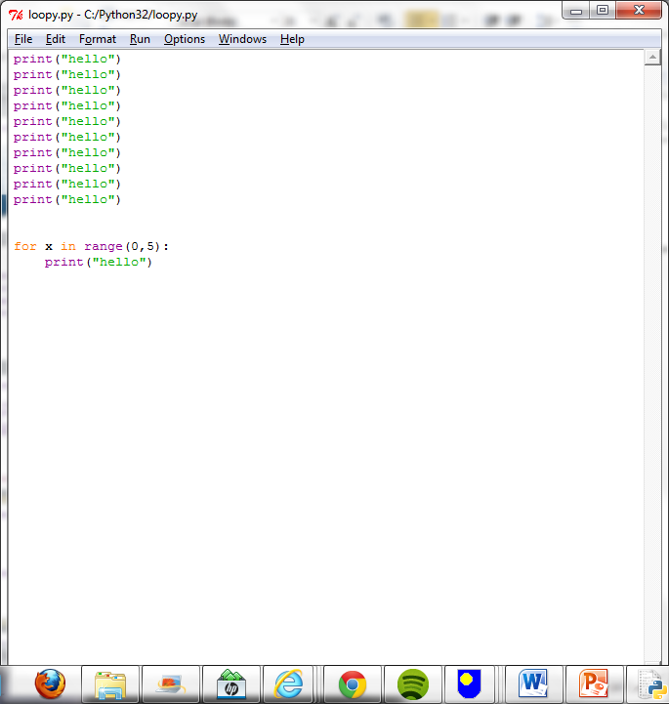

* Write a program that prints out “I like Kate Bush” 10 times.

**Activity 12.2**

* Copy and run this program:

for number in range(10):

print(number)

* Explain what this program does.

It prints out the numbers 0-9.

* Write a program that prints the numbers from 1 to 15.

for number in range(16):

* print(number)
* Write a program that prints the numbers from 1 to 8, with the square of each number, both on the same line.

For number in range (0,9):

print(number, number*number)

* Write a program that prints out the 9 times table (up to 20 x 9).

nine = (9)

for number in range (0,21):

print(number, number*nine)

* Write a program that asks the user which times table they want and then displays that table.
* Write a program that asks for a start value and an end value and then counts in fives between those numbers. *Hint: range(start value, end value, step)*

**Activity 12.3**

* Copy this program into a file and run the program.

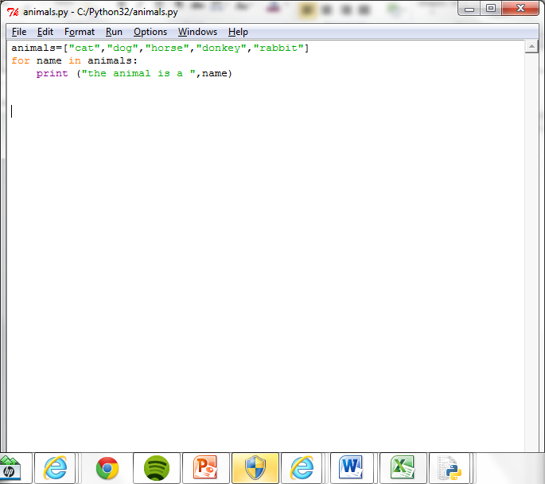

* Explain the purpose of the ‘name’ variable.
* Write a program that creates a list of things you would take to a desert island. The program should then display each item in the list a line at a time.

ditems=["water","backpack","food","map"]

for name in ditems:

print ("the ditems is a ", name)

**Activity 12.4**

Re-arrange the program statements to write a program that will print out the names of the animals that begin with the character ‘c’.

print(next)

if next[0] == "c" :

myList=["cat","dog","cow","donkey","rabbit","canary"]

for next in myList:

myList=["cat","dog","cow","donkey","rabbit","canary"]

for next in myList:

if next[0] == "c" :

print(next)

**Activity 12.5**

* 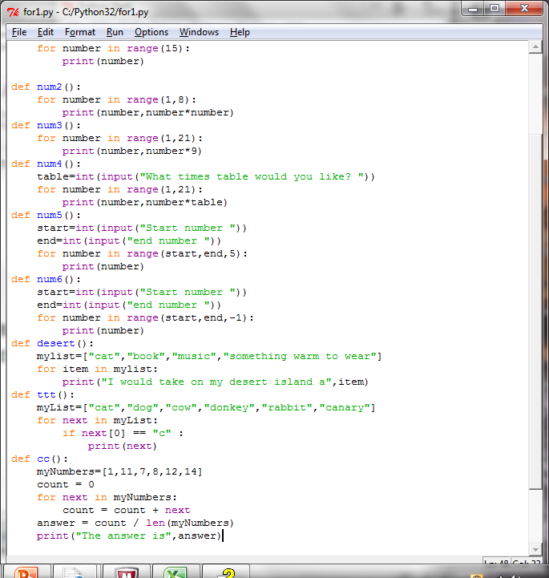Study this program.
* What will the program do?

It is meant to calculate.

* Explain what the variable next is used for?

Next number.

* Explain what the variable count is used for?
* What does len(myNumbers) do?

Calculates the length of the numbers.

* What happens if you add or append more numbers in the list?
* If a print statement was added to the for loop, as shown below, what would be displayed?

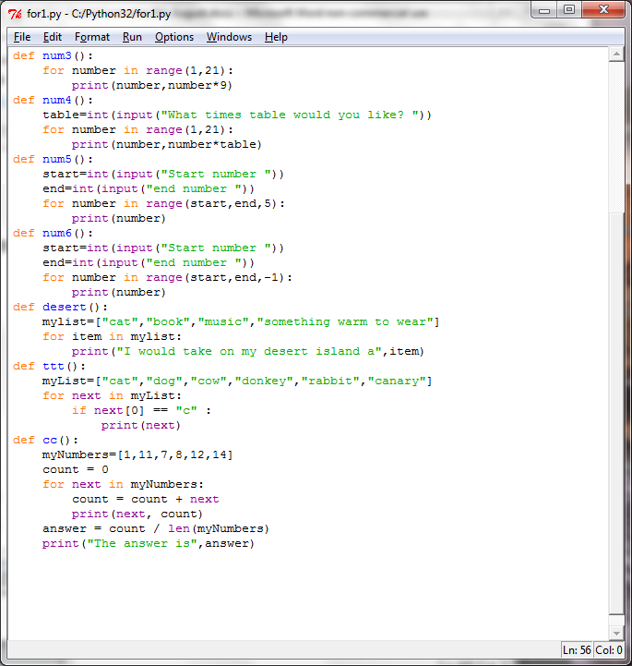**Activity 12.6**

Write a program that finds the largest number in this list.

myNumbers=[19,6,7,9,2,25,16]